DanceSport Grand Prix Canada 2023 Preferred Hotel

Special Group Rates – October 13 -16, 2023
Hilton Toronto/Markham Suites Conference Center & Spa

8500 Warden Avenue
Markham, ON L6G 1A5
Tel: 905-470-8500
www.torontomarkham.hilton.com

Standard Two Double Bed Suites
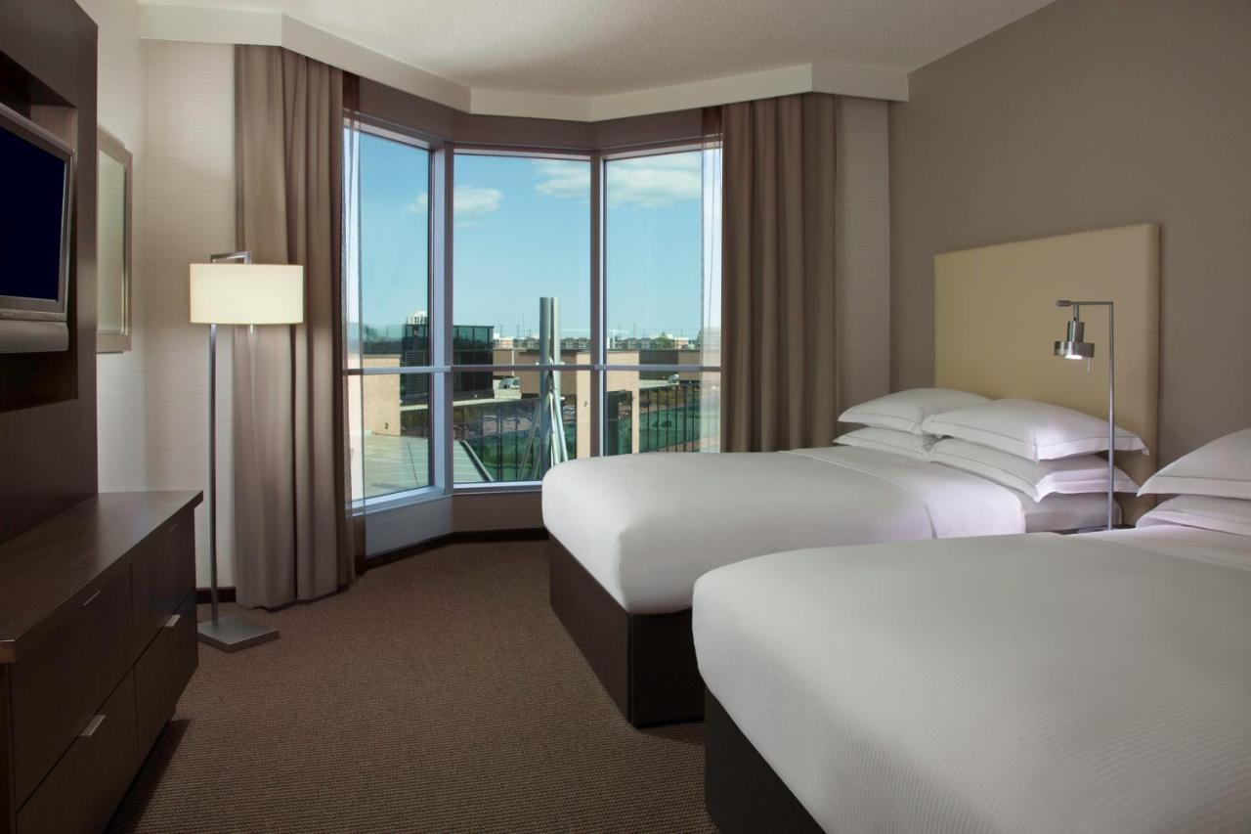
$199.00 single/double per night
$219.00 triple per night
$239.00 quad per night

Taxes and Fees: 13% HST, 4.52% MAT & 3% Common Facility Fee

Booking Link: https://www.hilton.com/en/attend-my-event/dancesportgrandprix2023/
OR

Book by Phone: 1-800-593-9223---press 1----speak to central reservation associate---GROUP CODE: 1DSC. A valid credit card is required to make and guarantee individual reservations online. Call the hotel directly should your dates of arrival or departure fall outside of the group dates.
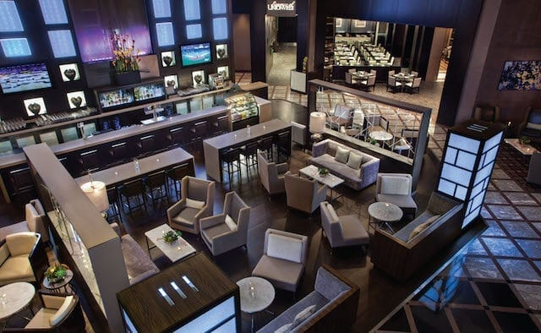
- Complimentary WiFi
- Complimentary Parking
- Discounted Breakfast for $18.00 ++ per person
- Numerous restaurants within 10 minutes
- Check in: 3pm Check out: 11am

Early Departure Fee: Confirmation of actual dates needs to be done prior to arrival or at check-in to avoid early departure fees. Currently $75.00, to the individual guest’s account.

Individual Cancellation: Reservations can be cancelled up to 48 hours prior to the day of arrival without penalty. Cancellations received after this cut off period, are subject to charge equivalent to 1-night room and tax to the individual credit card. No shows will be billed to the credit card on file. This cancellation clause supersedes the brand cancellation clause.

Check-In Time/Check-Out Time: 3pm / 11am

Group Rate Booking Cut Off: September 22, 2023

